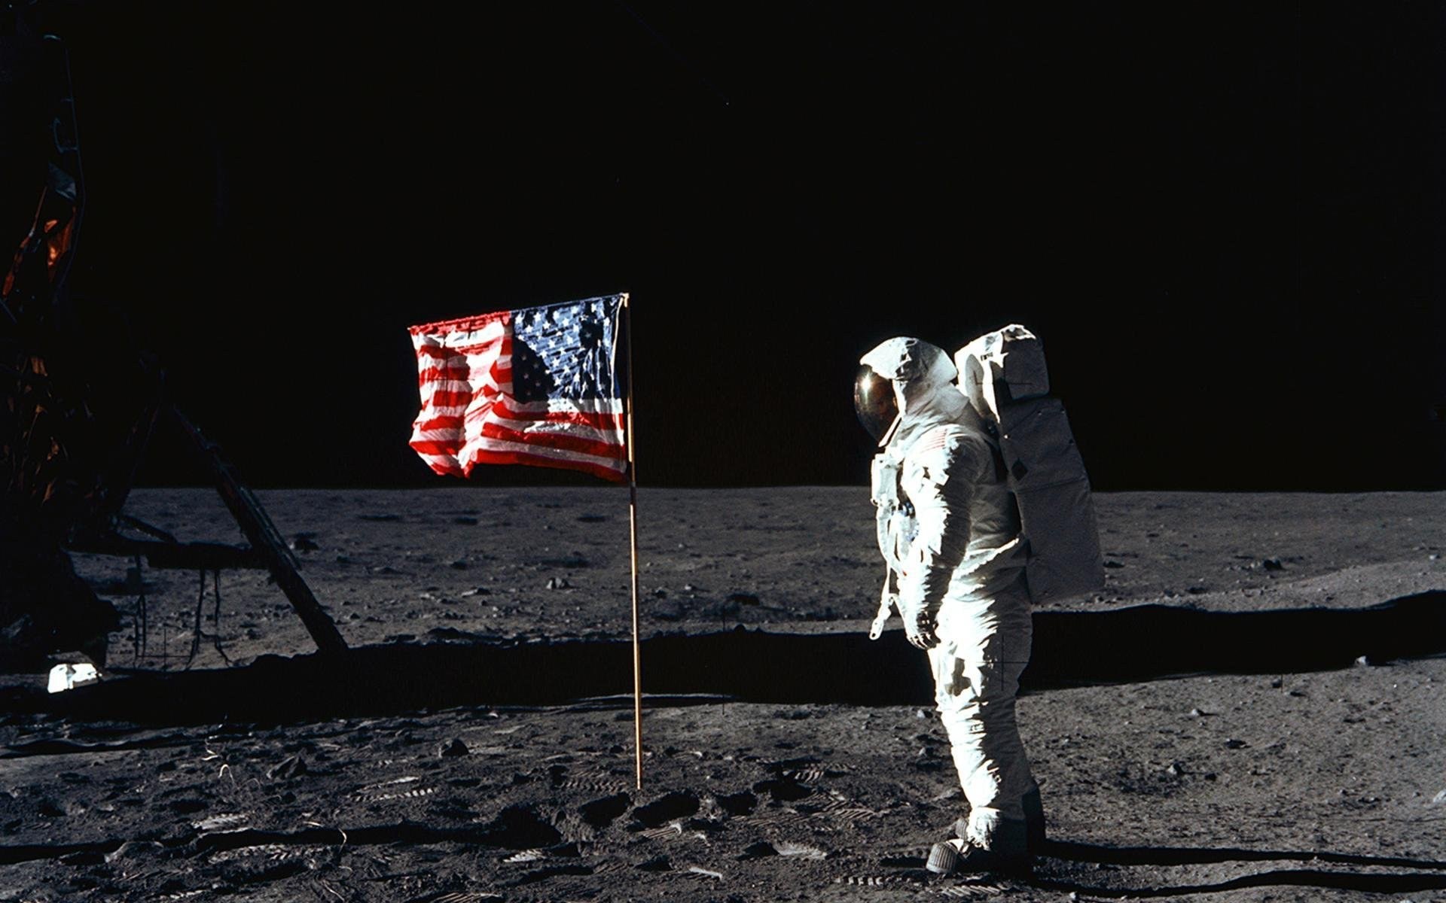

***Computer Hardware Based*** Astronaut

Career Assignment

By: Devdigvijay Singh | ICS 207 | Teacher: Ms. Xie

# Detailed Job Description

## General Astronauts

To replace the placeholder text on this page, you can just select it all and then start typing. But don’t do that just yet!

First check out a few tips to help you quickly format your report. You might be amazed at how easy it is.

* Need a heading? On the Home tab, in the Styles gallery, just click the heading style you want.
* Notice other styles in that gallery as well, such as for a quote, a numbered list, or a bulleted list like this one.
* For best results when selecting text to copy or edit, don’t include space to the left or right of the characters in your selection.

## Computer Programming / Computer Hardware Related Astronuats

You might like the photo on the cover page as much as we do, but if it’s not ideal for your report, it’s easy to replace it with your own.

Just delete the placeholder picture. Then, on the Insert tab, click Picture to select one from your files.

# Requirements

## Basic Requirements

Some of the very basic requirements, including educational requirements, to apply for employment as an astronaut in the Canadian Space Agency (CSA) include:

* Reside in Canada or be a Canadian citizen residing abroad; preference will be given to Canadian citizens
* Fluent in either English or French, but knowing both is a very useful asset
* Bachelor’s degree from a recognized university in engineering or other sciences, including biology, COMPUTER SCIENCE, COMPUTER HARDWARE, Earth and space sciences, etc.  
  OR  
  A doctorate in medicine or dentistry
* At least three years of relevant professional experience in whatever field the applicant specializes in or in a field related to space sciences  
  OR  
  Be licensed to practice medicine in Canada

## Physical and Medical Requirements

Employment as an astronaut is very physically and mentally demanding, so the applicant’s medical condition must be top-notch. Also, the space crafts that take humans from Earth into space have very specific requirements that cannot be worked around, simply because of the physics. Currently, there is only one space craft that can take humans to the International Space Station with a high enough success rate; the Soyuz capsule. Requirements are as follows:

* Height: Between 149.5 cm and 190.5 cm
* Weight: Between 50 kg and 95 kg
* Visual Acuity: 20/20 or better in each eye, with or without correction and without any complications  
  Most organizations hiring astronauts recommend that no applicant goes through eye correction only for becoming an astronaut and not for any other reasons
* Not colour blind
* Blood pressure: Not higher than 140/90 mm Hg, measured in a sitting position
* Auditory acuity: Applicant must have normal hearing